April 20th, 2008
Hi
Not much to write about. Last Wednesday, I visited the hospital again, the first time for four months. There was another rotation, but fortunately the doctor this time was one of the team that operated on me so he knew all about my case, unlike some of the others who have been on duty on past occasions. The main focus of attention was the lesion on my nose, the one I have had liquid nitrogen treatment on in the past. While there, I enquired about the head of the team who had treated me and was very friendly towards me, especially when he found out that I too was a professor. The chap on duty told me that he had died recently of colon cancer and that his funeral was on the actual day of my visit. Very sad.
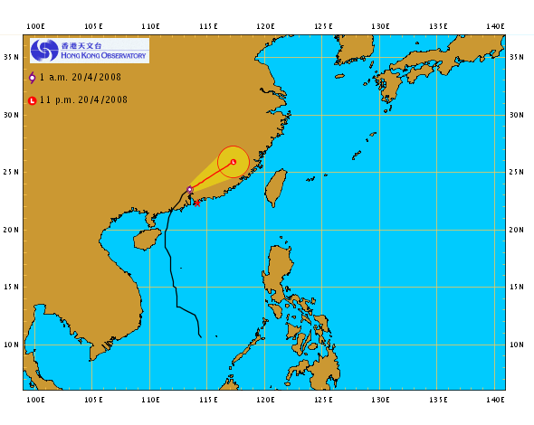
On Thursday, Typhoon signal 1 was hoisted, the second earliest since WWII. And then on Friday it was upgraded to number 3, which was the earlier #3 since WWII. Wind speeds of 180 km/h were recorded at the top of Lantau. They said that the reason for having a typhoon so early in the season was in part due to the ‘El Nino’ effect. (I have attached a file on the El Nino effect which was included in the teacher’s guide of the revised Singapore Science books.) The map shows the path of the typhoon. Yesterday, the #8 signal was raised in Macau but not in HK. (With this signal. everything closes down and people have to get home as soon as possible). It was quite wet and stormy last night though it is all over now and is actually very calm.

I went for a run yesterday. It was wet though as I have said before, I quite like running in the rain. This may be the last run for the season; I will only go next week if the weather is cool.
There have been trial runs in HK for the Olympic torch relay run to be held here some time in May. The first run was a week or so ago in the middle of the night. A second run along a revised and slightly shorter route was held yesterday during evening peak traffic time as that is the time the actual run will be held. Part of the relay includes the torch being carried down and across the Shing Mun river on a dragon boat accompanied by other dragon boats.

The Super 14 tournament continues. The Crusaders lost the latest round, their first defeat for the tournament though they are still leading. It was reported on the Planet Rugby website that Daniel Carter will probably join the ranks on the many other past and present All Blacks going overseas to play. The website said he is being offered ₤750 000 for a year to play for a French club! (From that, I am not sure if he will be away for just one year or not.) The NZ Rugby Football Union, understandably, is getting very worried about the exodus of top players as they are unable to offer the amounts of money that overseas clubs can offer.
This coming Friday, the 25th is Anzac Day. I have included again the pictures that were in last year’s letter (and I think the year before) related to the Gallipoli landings.
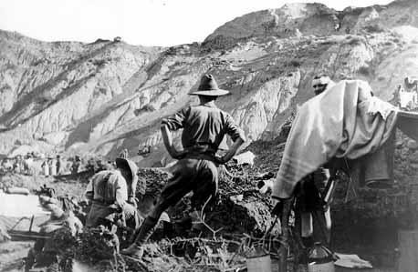
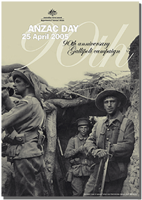
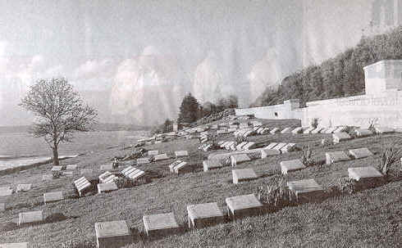
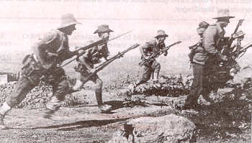
Cheers

